AUTOMATED RESUME ANALYSIS USING NLP
- Jenifer ¹, M. Sukanya ²,
Student ¹, Assistant Professor ²,
PG Department of Data Science,
Holy Cross College (Autonomous), Tiruchirappalli.
ABSTRACT
This project employs spaCy for entity recognition on 200 resumes and explores diverse NLP tools for text analysis, aiming to streamline the recruitment process for recruiters dealing with large volumes of applications. The primary focus is to expedite application review, enabling hiring managers to sift through numerous resumes efficiently. The inclusion of a skills match feature introduces a metric for hiring managers to assess alignment with job requirements, aiding in swift decision-making on candidate progression to the interview stage. Utilizing two datasets – one with resume texts and another with skills – an entity ruler is created for enhanced entity recognition. This project seeks to provide a practical solution for recruiters by leveraging NLP techniques, emphasizing speed and precision in candidate evaluation within a modern recruitment context.
Keywords: Natural language processing (NLP), SpaCy, Sentiment Analysis
I. INTRODUCTION
This project is centered around the implementation of spaCy for entity recognition within a dataset comprising 200 resumes, complemented by a comprehensive exploration of various NLP tools for text analysis. The overarching objective is to revolutionize the recruitment process, specifically addressing the challenge of navigating through a substantial volume of applications efficiently. The primary aim is to empower recruiters to swiftly and effectively review hundreds of resumes within minutes. To augment the decision-making process for hiring managers, a skills match feature has been integrated. This feature provides a metric for assessing the alignment between applicants' skills and job requirements, facilitating a streamlined and informed approach to candidate selection. The project is grounded in two core datasets: the first encompasses textual content extracted from 200 resumes, offering a diverse array of candidate profiles for analysis. The second dataset consists of a curated list of skills, strategically utilized to construct an entity ruler. This ruler serves as a valuable resource for the entity recognition process, specifically targeting entities related to skills, qualifications, and experience.
The unique contribution of this project lies in its commitment to addressing the time-intensive nature of candidate screening. By combining the power of spaCy for entity recognition and a custom entity ruler for skills matching, the project anticipates a substantial reduction in the time and effort traditionally associated with resume evaluation. The proposed outcomes seek to provide hiring managers with a rapid and precise mechanism for assessing and shortlisting candidates, thereby expediting the recruitment pipeline. Through its pioneering approach to leveraging advanced NLP techniques, this research represents a scalable and effective solution for modern talent acquisition challenges, emphasizing the project's significance in the evolving landscape of high-volume recruitment.
II. REVIEW OF LITERATURE
Channabasamma et al [1]: This paper suggests a machine learning method for phrase matching in resumes, utilizing the advanced natural language processing (NLP) library spaCy to extract particular skills. Like a human recruiter, it is capable of analyzing resumes and extracting comprehensive information. In order to classify people according to their level of expatriation, it counts the sentences during parsing. Data visualization with matplotlib can expedite the decision-making process. It is possible to weed out candidates by comparing them side by side.
Chavare, Dipti Suhas et al [2]: This article uses advanced Natural Language Processing to automate the screening of resumes. Our methodology assists recruiters in quickly screening resumes in accordance with job descriptions. By automatically extracting the necessary entities from resumes using the Spacy NER model, it streamlines the hiring process. Additionally, joint NER and relation extraction offer a whole new way to retrieve information using knowledge graphs, allowing you to explore different nodes to uncover hidden relationships.
Satheesh, K., A. Jahnavi et al [3]: This paper inefficiencies of manual resume screening in traditional hiring processes and proposes an automated solution using advanced Natural Language Processing (NLP) within the realm of Machine Learning. The model employs Spacy NER for entity extraction, streamlining the screening process and providing recruiters with a graphical representation of candidate scores. This approach not only accelerates hiring but also enhances efficiency by enabling recruiters to swiftly identify and select qualified candidates based on their individual scores.
Shukla, Anant [4]: Beyond simple spell checking, the applicant tracking system (ATS) grades applications using cutting edge AI technology based on many checks that hiring managers and recruiters review. In particular, the platform assesses word choice strength and verifies application style and brevity in order to analyze the impact of the application. In a similar vein, it evaluates every application bullet point and looks for important components including length, word choice, filler words, keywords, and buzzwords.
Vanetik, N. and Kogan [5]: We provide a dataset of software developer resumes in this paper, taken from a public Telegram channel devoted to Israeli hi-tech job applications. Furthermore, to attain state-of-the-art performance in resume matching, we offer an NLP-based method that makes use of named entities, keywords, and neural sentence representations. We compare our method against the top resume-vacancy matching system and show its superiority using both automatic and human annotations.
Bhoir, Nirmiti et al [6]: The two algorithms' best features are combined in this work to obtain highly accurate and effective resume data collection. We conducted experiments to measure the effectiveness of our proposed approach using a dataset of resumes. The results show how accurately our system was able to retrieve relevant data, such as candidate names, contact details, qualifications, job history, and other relevant attributes.
Brindashree, B.V. and Pushphavathi [7]: The decision tree machine learning model, which had a 70% accuracy rate, was trained to make the prediction. The data's precision, recall, and f1 score are acquired and used to assess how successfully the data was trained. Overall, the initiative will streamline HR duties and automate procedures, which will shorten the duration of the hiring process.
S. Hashwanth et al [8]: Recruiters may easily shortlist resumes fast and effectively by processing the document ranking and displaying the final rankings in descending order based on the resume score. Instead of going through piles of unqualified resumes, recruiters may select the necessary candidates based on the scores.
Tanberk, Senem et al [9]: The suggested resume matching framework lets managers or recruiters choose the top-scoring applicants by precisely extracting pertinent information from resumes and displaying the similarity results of the candidates through sorting and ranking.
Chavare, Dipti Suhas et al [10]: This article uses advanced Natural Language Processing to automate the screening of resumes. Our methodology assists recruiters in quickly screening resumes in accordance with job descriptions. By automatically extracting the necessary entities from resumes using the Spacy NER model, it streamlines the hiring process. Additionally, joint NER and relation extraction offer a whole new way to retrieve information using knowledge graphs, allowing you to explore different nodes to uncover hidden relationships.
Sruthi, P., Adithya et al [11]: The information on the resume can be analysed and understood easily as NLP has the capability to understand and parse the information on the resume and extract the desired information efficiently. With the additional help from Python and its packages like streamlit, pymysql, etc. we can store the extracted data and give a rating based on the analysis of the stored data. After the rating is generated, we recommend some modifications like: adding sentences like my hobbies are, my goal is, add objectives, and add declaration and more. We also suggest a few sources through which the user can enhance their skills.
III. PROBLEM STATEMENT
In the contemporary job market, recruiters grapple with the challenge of efficiently managing a vast influx of job applications. Manual screening processes lead to delays and potential oversights, while traditional resume analysis methods lack of sophistication. Existing tools often fall short in accurately identifying skills, experiences and manual parsing is labor-intensive and error-prone. Addressing these challenges demands advanced NLP techniques, particularly spaCy for entity recognition and entity ruling, complemented by robust skills matching algorithms. The project pioneers an NLP-driven solution to revolutionize resume analysis aiming to expedite candidate selection and enhance hiring efficiency, prioritizing, scalability and usability for recruiters in the dynamic job market.
IV. EXISTING SYSTEM
One existing system for spaCy resume analysis is "Resumé Parser," an open-source Python library built on top of spaCy. Resumé Parser provides functionalities for parsing resumes in various formats such as PDF, DOCX, and TXT, extracting key information like personal details, work experience, education, and skills. It utilizes spaCy's natural language processing capabilities to perform entity recognition and extraction, enabling efficient parsing and structuring of resumes. Resumé Parser offers a straightforward API that developers can integrate into their applications to automate the resume screening and analysis process, saving time and effort for recruiters and HR professionals. Another existing system is "Talent Sonar," a commercial HR software solution that leverages spaCy for resume analysis and candidate screening. Talent Sonar utilizes spaCy's NLP capabilities to parse resumes, extract relevant information, and match candidates with job requirements based on skills, experience, and qualifications. It provides advanced features such as customizable scoring algorithms and bias detection mechanisms to streamline the recruitment process and ensure fair and unbiased candidate evaluation. Talent Sonar offers a user-friendly interface for recruiters to manage and analyze resumes efficiently, helping organizations identify top talent effectively while minimizing manual effort and bias.
V. PROPOSED SYSTEM
The proposed automated resume analysis system represents a groundbreaking advancement in the field of talent acquisition, leveraging cutting-edge Natural Language Processing (NLP) techniques with a primary focus on spaCy. By integrating spaCy for entity recognition and implementing a custom entity ruler for skills matching, the system efficiently extracts key information from a dataset of 200 resumes, streamlining candidate screening. The introduction of a skills matching metric provides hiring managers with a quantitative basis for decision-making, allowing for swift identification of candidates closely aligned with job role requirements. Operating on two primary datasets, including textual content of resumes and a curated list of skills, the system optimizes efficiency, empowering recruiters with a rapid and precise mechanism for candidate evaluation. The anticipated outcomes include an effective solution for high-volume resume screening, scalability for evolving recruitment needs, and a user-friendly interface ensuring a seamless experience for recruiters. Positioned as a pioneering effort in applying advanced NLP techniques, the system is designed for continuous improvement, adapting to changing job market dynamics and emerging recruitment trends, ultimately enhancing the overall recruitment process.

VI. METHODOLOGY
The Automated Resume Analysis Using spaCy employs a systematic methodology for efficient recruitment processes. It begins with collecting resumes in various formats, parsing them using spaCy for text extraction, and leveraging NLP capabilities for tasks like named entity recognition and part-of-speech tagging. Extracted data is structured in a database, incorporating keyword matching and sentiment analysis for candidate evaluation. Operating on diverse datasets, the project features 200 resumes and a curated list of skills, forming a custom entity ruler. The synergy between spaCy's entity recognition and the skills-matching entity ruler promises innovation in resume analysis, ensuring reduced screening time and a groundbreaking approach to quantitative skills alignment measurement.

Fig. 1: Resume Analysis
6.1. SPACY:
SpaCy, a cutting-edge NLP library, is revolutionizing resume analysis with its advanced Named Entity Recognition (NER) model. This technology automates and streamlines the screening process by seamlessly extracting crucial details like skills and experiences, boosting efficiency and accuracy. SpaCy's intelligent automation shifts from manual screening, providing recruiters with a comprehensive understanding of applicants' profiles for informed decision-making. This transformative advancement reduces time and effort, allowing recruiters to focus on evaluating the most qualified candidates, promising enhanced productivity in hiring processes. In summary, SpaCy's role in resume analysis signifies a pivotal shift towards more efficient and informed recruitment practices.
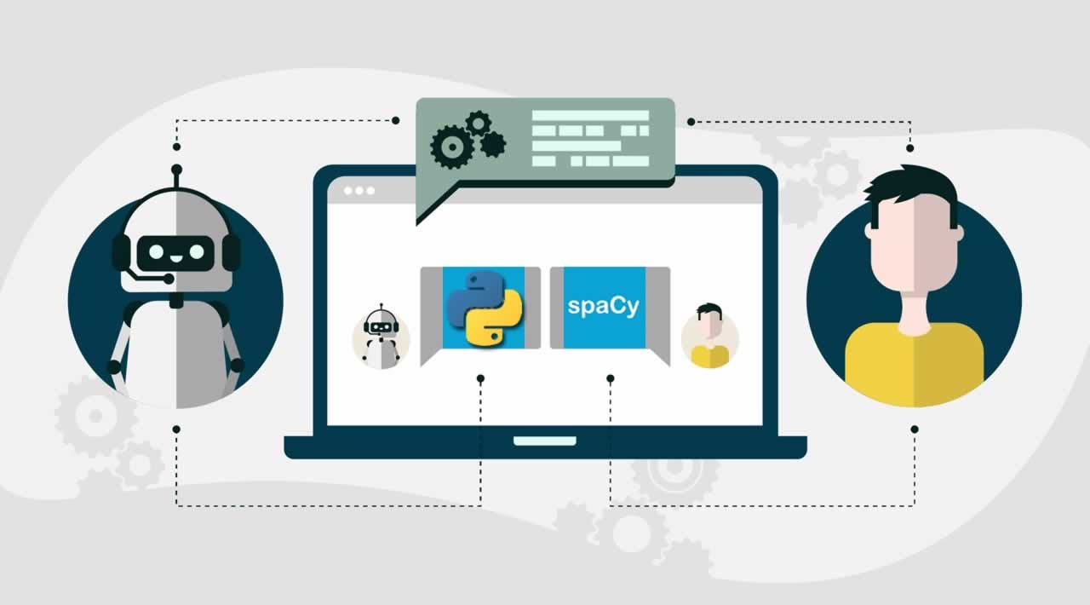
Fig. 2: SpaCy using NLP
6.2. Dataset:
The dataset for Automated Resume Analysis Using spaCy encompasses diverse resumes from various industries, providing structured information like education, work experience, skills, and contact details. It includes different formats (PDF, DOCX, plain text) and incorporates unstructured sections, such as objectives and project summaries. Annotated with named entities, it facilitates spaCy NLP model training for accurate parsing. The CSV dataset, with a unique identifier and categories, supports text-based analysis, HTML format examination, and research in automated resume analysis across a spectrum of professions and industries.
6.3. DATA FLOW DIAGRAM:
Dataset

Cleaning Resume Text
Entity Ruler

Jobs Distribution

Visualization
Dependency Parsing

Entity Recognition
Resume Analysis

pyLDAvis
LDA

Fig. 3: SpaCy Resume Analysis
6.4. Jobzilla skill patterns:
The Jobzilla skill patterns dataset, stored in JSONL format, is a key asset for developing a spaCy entity ruler tailored for automated resume analysis. Comprising labeled skill patterns, it covers a diverse range of skills commonly found in resumes across industries. Each entry includes a label categorizing the skill and associated patterns, such as "Python programming" or "project management." By integrating this dataset, the automated system gains precision in recognizing and extracting specific skills, improving the efficiency of resume analysis. The dataset also allows for continuous customization and adaptation to evolving job market demands, contributing to the system's ongoing effectiveness.

6.5. Loading spaCy model:
After downloading the spaCy model with "python -m spacy download en_core_web_lg," the next step involves loading the model into Python. This is achieved by importing spaCy and using "spacy.load" to load the "en_core_web_lg" model, stored in a variable named "nlp." This model, being a large English language model, offers diverse linguistic features like part-of-speech tagging and named entity recognition. Access to such rich linguistic representations forms the basis for NLP tasks, essential for automated resume analysis.
6.6. Entity Ruler:
Adding the entity ruler pipeline to our spaCy model is crucial for automated resume analysis. By defining rules and loading labeled patterns from a .jsonl file, we empower the model to recognize and annotate specific entities like skills and job descriptions in resumes. This enhancement enables precise information extraction, improving the system's robustness and effectiveness, ultimately streamlining recruitment and providing valuable insights for decision-making.
6.7. Skills:
The unique_skills function in our automated resume analysis system plays a vital role in processing and organizing extracted skills. After the get_skills function extracts skills from a resume text, unique_skills eliminates duplicates, ensuring a concise and accurate summary. This step enhances interpretability, streamlines analysis, and empowers recruiters to make informed decisions based on clear representations of candidates' skills across job categories.
6.8. Cleaning Resume Text:
Cleaning resume text using the NLTK library involves crucial steps. Initial use of regex eliminates hyperlinks, special characters, and punctuations. Lowercasing standardizes the text, and lemmatization reduces words to base forms, enhancing consistency. Removal of stop words and subsequent array formation ensures the data is ready for accurate analysis and insightful trend extraction.
6.9. Visualization:
In visualizing job and skill distributions from our spaCy-based resume analysis, we aim to provide a comprehensive dataset overview. Bar or pie charts for job distributions reveal prevalent industries, while word clouds, bar charts, or heatmaps for skill distributions showcase in-demand skills across job categories. These visualizations empower recruiters with insights for talent acquisition, skill gap analysis, and effective workforce planning.
6.10. Entity Recognition:
The spaCy function displacy.render proves to be a robust tool for visualizing entity recognition in raw text data. It generates interactive visualizations highlighting entities like skills, organizations, and locations in resumes. These visualizations offer a user-friendly interface for exploring and understanding text structure, aiding in information extraction. The customization options enhance its utility, making displacy.render invaluable for entity recognition insights in textual data.
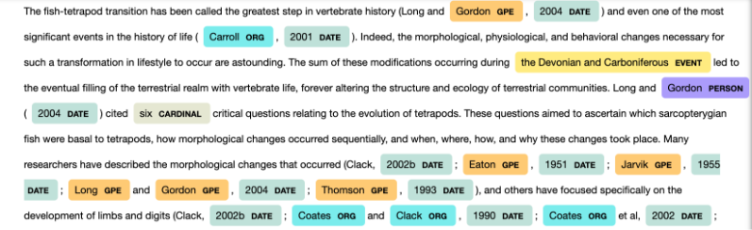
Fig. 4: Resume dataset Entity Recognition
6.11. Dependency Parsing:
Utilizing spaCy's displacy.render function with the "dep" style is a valuable approach to comprehend grammatical structures within text. By specifying this style, it generates visual representations illustrating syntactic dependencies between words, showcasing relationships like subject or object. The option to limit words provides a focused view, aiding in analysis, while removing the limit offers a comprehensive overview of dependencies. This visualization technique proves invaluable for tasks like syntactic analysis, information extraction, and enhancing natural language understanding.
6.12. Custom Entity Recognition:
In our customization, a new entity "SKILL" is introduced and displayed in gray. Dissatisfied with colors, I experimented by incorporating a job description entity and adjusting displacy settings:
- Added Job-Category to the entity ruler.
- Assigned unique hues to each category.
- Introduced gradient colors for both SKILL and Job-Category entities, enhancing visual distinction in the display.
6.13. Topic Modeling – LDA:
Latent Dirichlet Allocation (LDA) is a widely used topic modeling algorithm, representing documents as mixtures of topics, each modeled as a word distribution. With 4 topics, LDA uncovers main themes in the corpus, aiding insights into dominant topics and supporting document categorization, summarization, and information retrieval tasks. This methodology proves valuable for understanding and organizing large text datasets.
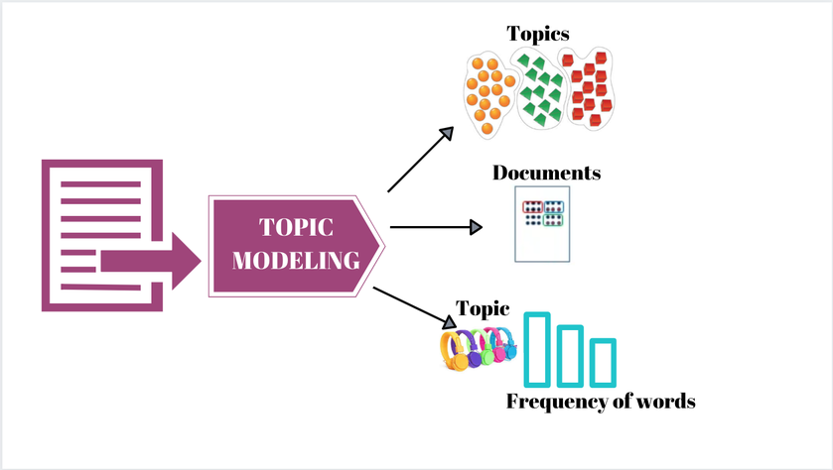
Fig. 5: Latent Dirichlet Allocation
6.14. PyLDAvis:
PyLDAvis is a potent tool for visualizing LDA-generated topics, providing clear insights in the described context:
- Customer-related topics encompass discussions on service, satisfaction, demographics, and geographical locations.
- Management and marketing themes reveal insights into strategic practices, campaigns, and market analysis.
- Systems and projects discussions include software engineering, development, and implementation strategies.
Financial and company-related topics involve conversations on financial management, investments, performance, and governance. PyLDAvis aids stakeholders in deeper topic interpretation, exploration, and refining understanding of underlying content relationships.
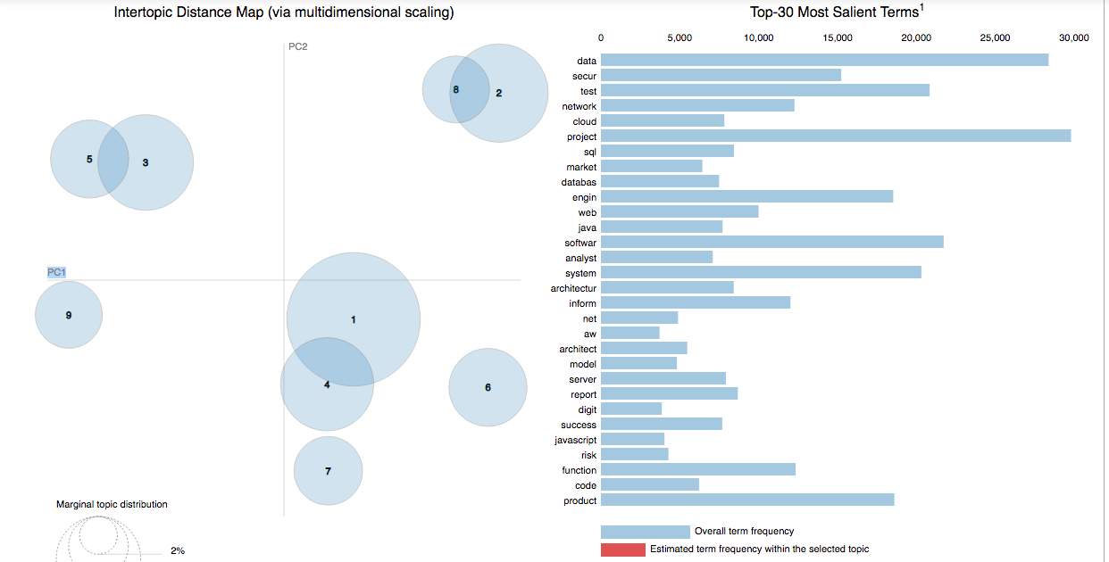
Fig. 6: Intertopic Distance Map

VII. IMPLEMENTATION
7.1. Jobs Distribution:
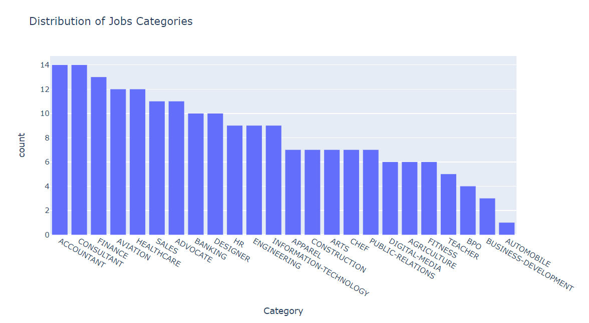
Fig. 7: Job Categories

7.2. Skills:
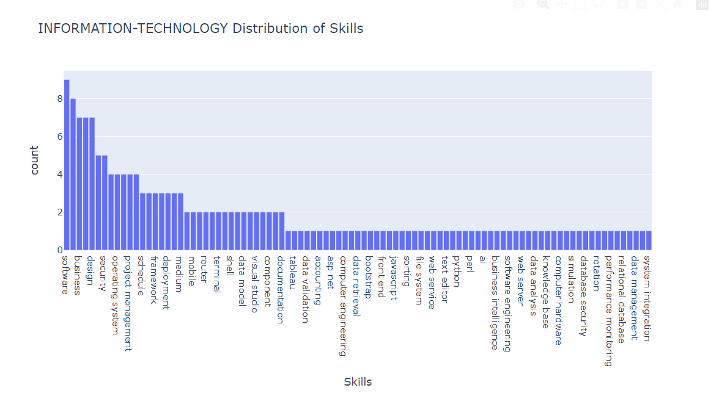
Fig. 8: Skill Distribution
7.3. Most used words:
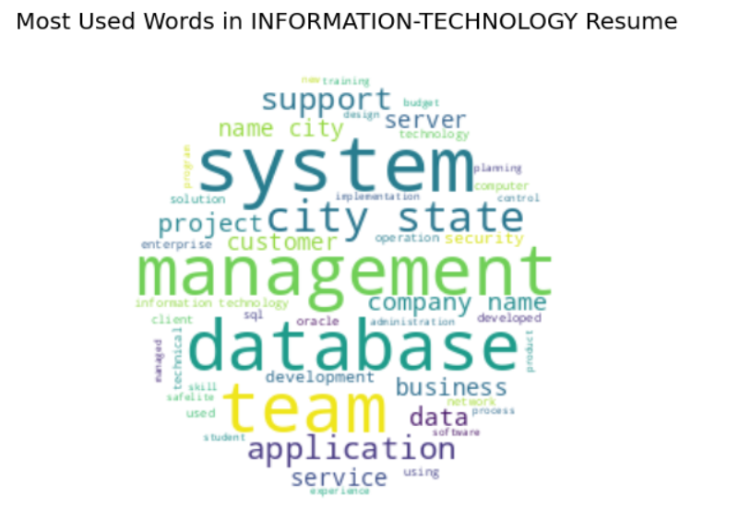
Fig. 9: Most Used Words

7.4. Entity Recognition:
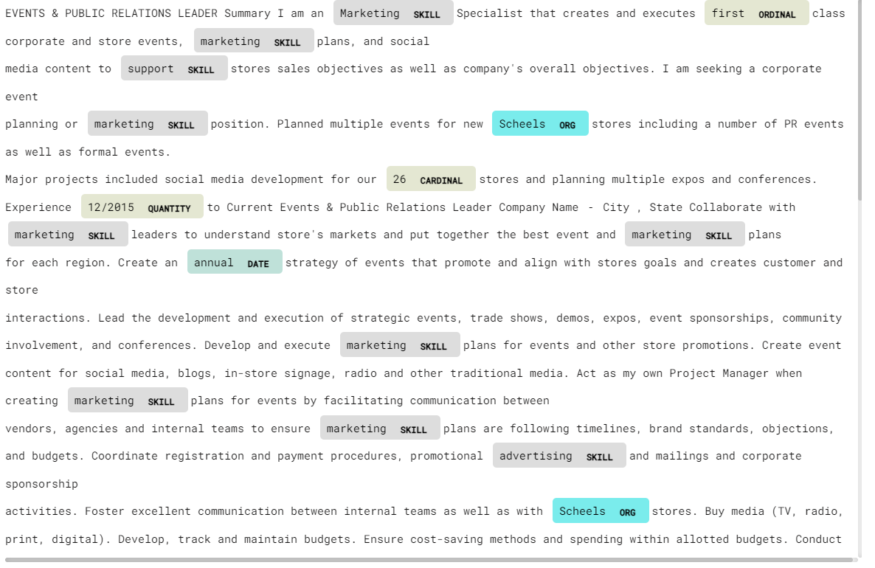
Fig. 10: Entity Recognition
7.5. Dependency Parsing:
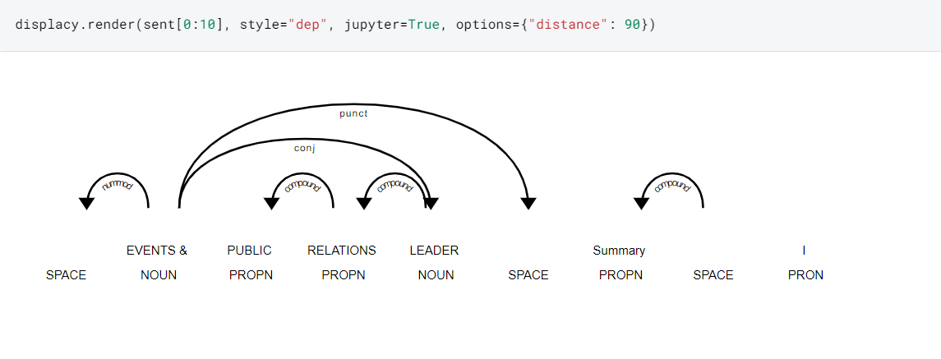
Fig. 11: Dependency Parsing

7.6. Custom Entity Recognition:
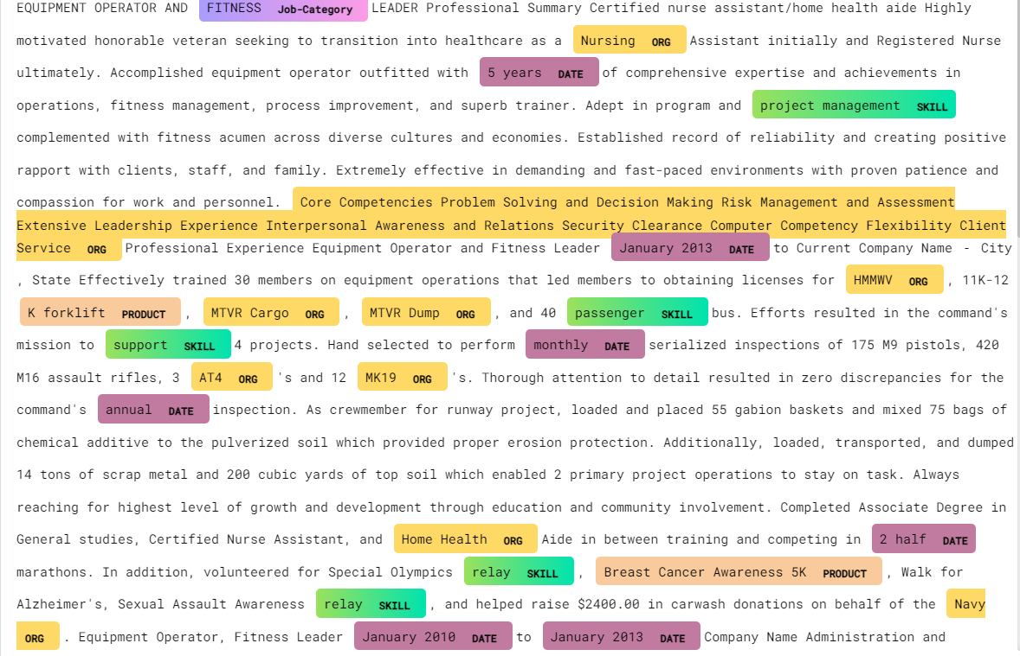
Fig. 12: Custom Entity Recognition
7.7. Resume Anlaysis:
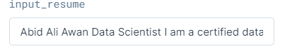
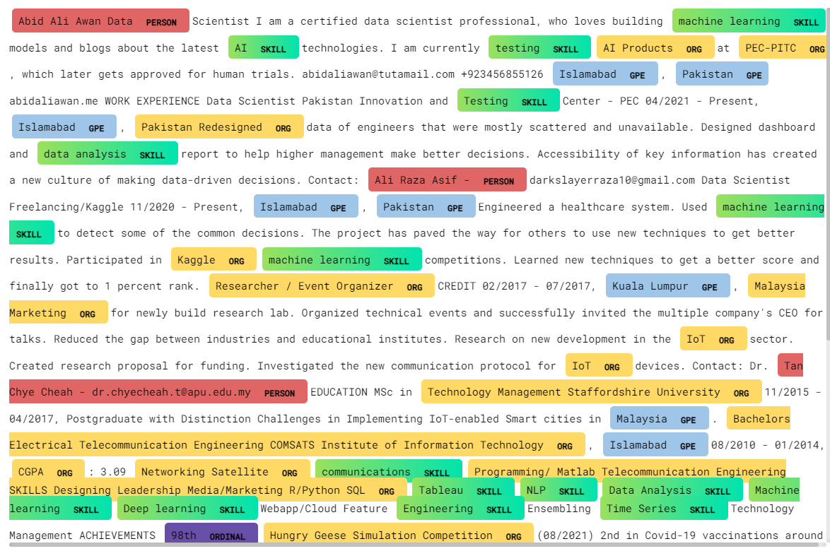
Fig. 13: Resume Analysis

7.8. pyLDAvis:
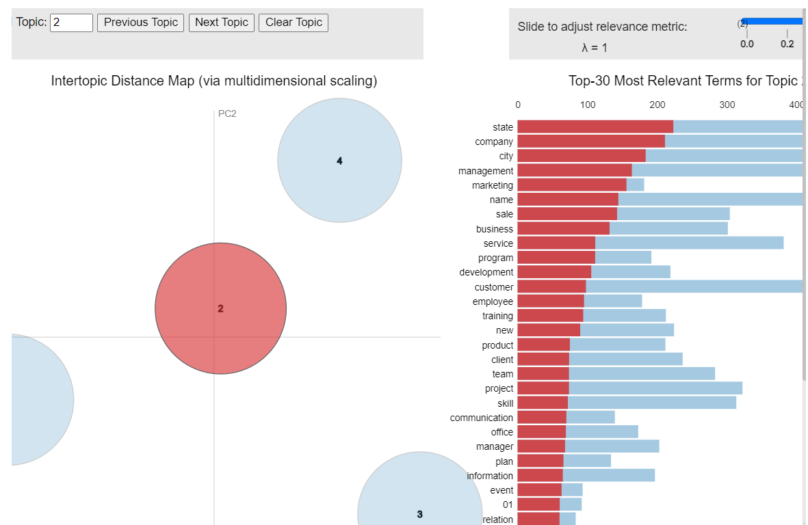
Fig. 14: pyLDAvis visualizations
VI. CONCLUSION
Our collaboration with spaCy in this project has been transformative, harnessing its entity ruler and customized visualizations for enriched analyses. The seamless integration of skills distribution visualization enhances recruiters' ability to swiftly identify candidates with desired skillsets, optimizing the recruitment process. The incorporation of Latent Dirichlet Allocation (LDA) and pyLDAvis visualization deepens insights into textual themes, marking a significant stride in reshaping and modernizing candidate screening and evaluation processes. This project highlights the transformative potential of natural language processing in revolutionizing talent acquisition strategies.
REFERENCES
[1] SW. Kim, JM. Gil, Research paper classification systems based on TF-IDF and LDA schemes. Hum. Cent. Comput. Inf. Sci. 9, 30 (2019).
[2] F. N. A. Al Omran and C. Treude, "Choosing an NLP Library for Analyzing Software Documentation: A Systematic Literature Review and a Series of Experiments," 2017 IEEE/ACM 14th International Conference on Mining Software Repositories (MSR), Buenos Aires, 2017, pp. 187-197.
[3] Zhang C, Wang H (2018) ResumeVis: a visual analytics system to discover semantic information in semi-structured resume data. ACM Trans Intell Syst Technol 10(1), Article 8, 25 p. https://doi.org/10.1145/3230707.
[4] Chala, S.A.; Ansari, F.; Fathi, M.; Tijdens, K. Semantic matching of job seeker to vacancy: A bidirectional approach. Int. J. Manpow. 2018, 39, 1047–1063.
[5] Pudasaini, S.; Shakya, S.; Lamichhane, S.; Adhikari, S.; Tamang, A.; Adhikari, S. Scoring of Resume and Job Description Using Word2vec and Matching Them Using Gale-Shapley Algorithm. In Proceedings of the ICOECA 2021, Bangalore, India, 18–19 February 2021.
[6] Kawan, S.; Mohanty, M.N. Multiclass Resume Categorization Using Data Mining. Int. J. Electr. Eng. Technol. 2020, 11, 267–274.
[7] R. P. Kumar, S. S. Chowdhary and R. Bhatia, "A machine learning approach for automation of resume recommendation system", Procedia Computer Science, vol. 167, pp. 2318-2327, 2020.
[8] T. Quynh and T.T. Dang, "Automatic Process Resume In Talent Pool By Applying Natural Language Processing", International Conference On Logistics And Industrial Engineering 2021, 2021.
[9] S. K. Kopparapu, "Automatic extraction of usable information from unstructured resumes to aid search," 2010 IEEE International Conference on Progress in Informatics and Computing, Shanghai, 2010, pp. 99-103.
[10] Chandola, D., Garg, A., Maurya, A., Kushwaha, A.: Online Resume Parsing System Using Text Analytics (2015). [online] Jmdet.com. Available at: http://www.jmdet.com/wp-content/uploads/2015/08/CR9.pdf. Accessed 24 Sept. 2020.

